|  |  |  |  |  |  |
| --- | --- | --- | --- | --- | --- |
| **Module No:** | 1 | **IU No:** | 3 | **Exercise No.** | 1 |

|  |  |
| --- | --- |
| **Lab Assessment Statement** | **Assignment 3 - Spring Boot**  **Let’s build on the previous assignment.**   1. **Create a Spring Boot application for “Know-Your-Neighborhood”.** 2. **Add support for JSP views and create required folder structure.** 3. **Move already developed classes into this project.** 4. **Develop all components required to view the stores**    1. **Add method to existing Controller class to receive the request to fetch stores**    2. **Add method to existing Service class to process the request (or add method to existing service class)**    3. **Add method existing repository class to return all available stores.**    4. **Create HTML to view the stores. Show name, phone number and localities it serves for each store.**    5. **Ensure that view stores request works end-to-end. (i.e., should be able to submit request to view the stores in the browser and get the page back with all stores).** 5. **Create an HTML page to add a store and link it to the view stores page.** 6. **Let the response of add request submission be the view page that shows all stores including recently added store.** |
| **Technical Environment** | - |
| **Guidelines** | - |
| **Duration** | 120 mins |

1. **Create a Spring Boot application for “Know-Your-Neighborhood”.**

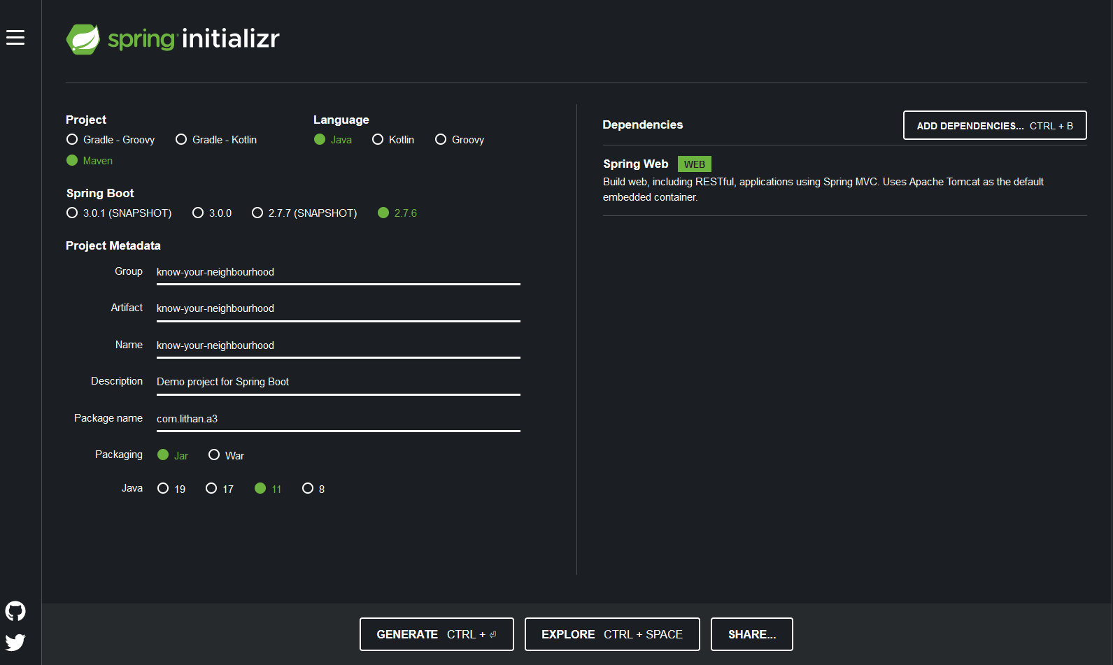

1. **Add support for JSP views and create required folder structure.**

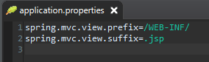

1. **Move already developed classes into this project.**

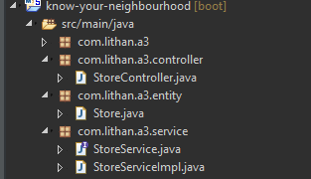

1. **Develop all components required to view the stores**
   1. **Add method to existing Controller class to receive the request to fetch stores**

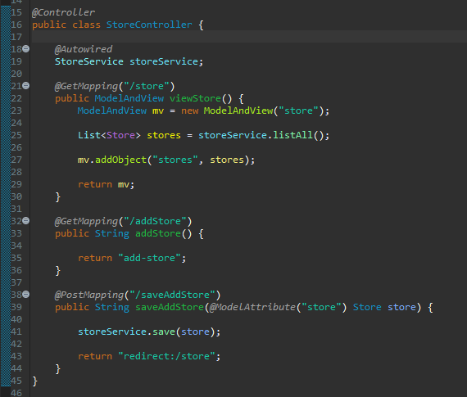

* 1. **Add method to existing Service class to process the request (or add method to existing service class)**

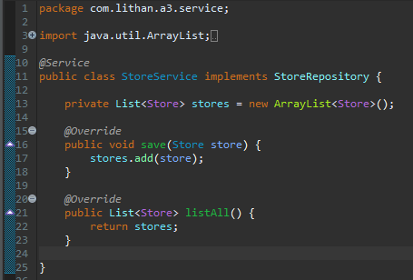

* 1. **Add method existing repository class to return all available stores.**

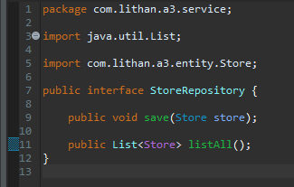

* 1. **Create HTML to view the stores. Show name, phone number and localities it serves for each store.**

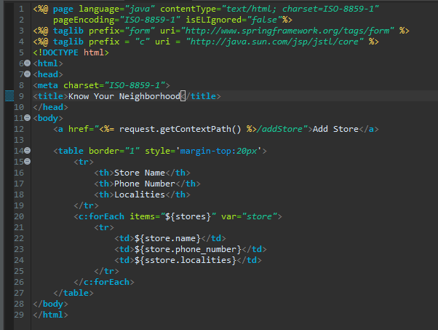

* 1. **Ensure that view stores request works end-to-end. (i.e., should be able to submit request to view the stores in the browser and get the page back with all stores).**

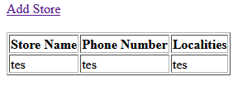

1. **Create an HTML page to add a store and link it to the view stores page.**

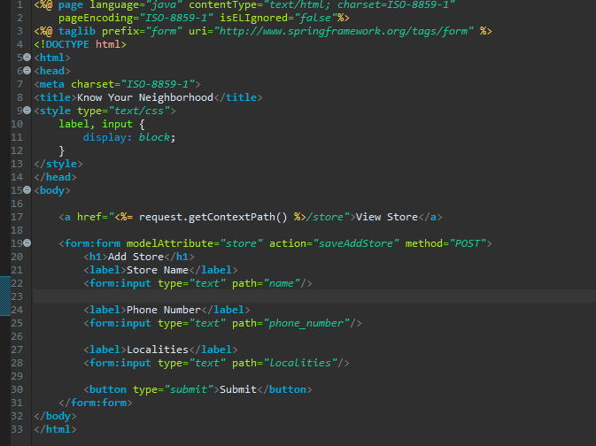

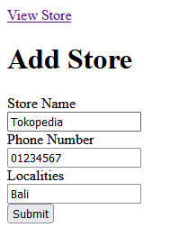

1. **Let the response of add request submission be the view page that shows all stores including recently added store.**

